LEARNOVA INTERNSHIP PROGRAM
Project Submission Report
Submitted By:
Sanchi Kondekar
Third Year Computer Engineering Student
Submission Date:
15 June 2026
Project Documentation
Technologies Used
- HTML5
- CSS3
- JavaScript

Introduction
This document provides an overview of the projects completed as part of the Learnova Internship Program. The objective of these tasks was to demonstrate practical knowledge of front-end web development, responsive design, user interface development, and JavaScript programming.
The repository contains three projects:
- Portfolio
- Temperature Converter Website
- Tribute Page

Project 1: Portfolio
Project Overview
The Portfolio website was developed to showcase my educational background, technical skills, projects, and career interests in a professional and organized manner. The website serves as a digital portfolio that highlights my journey as a Computer Engineering student and aspiring software developer.
Objectives
- Create a professional portfolio website
- Present personal and academic information effectively
- Showcase technical skills and projects
- Build a responsive and visually appealing user interface
Features Implemented
- Responsive navigation bar
- Hero/Home section
- About Me section
- Skills section
- Education section
- Responsive design
- Projects section
- Currently section
- Contact section
- Smooth scrolling navigation
Technologies Used
- HTML5
- CSS3
- JavaScript
My Contribution
I independently designed and developed the complete portfolio website. I structured all website sections, implemented responsive layouts, styled the interface using CSS, and enhanced the user experience through modern design principles and interactive elements.
Screenshots

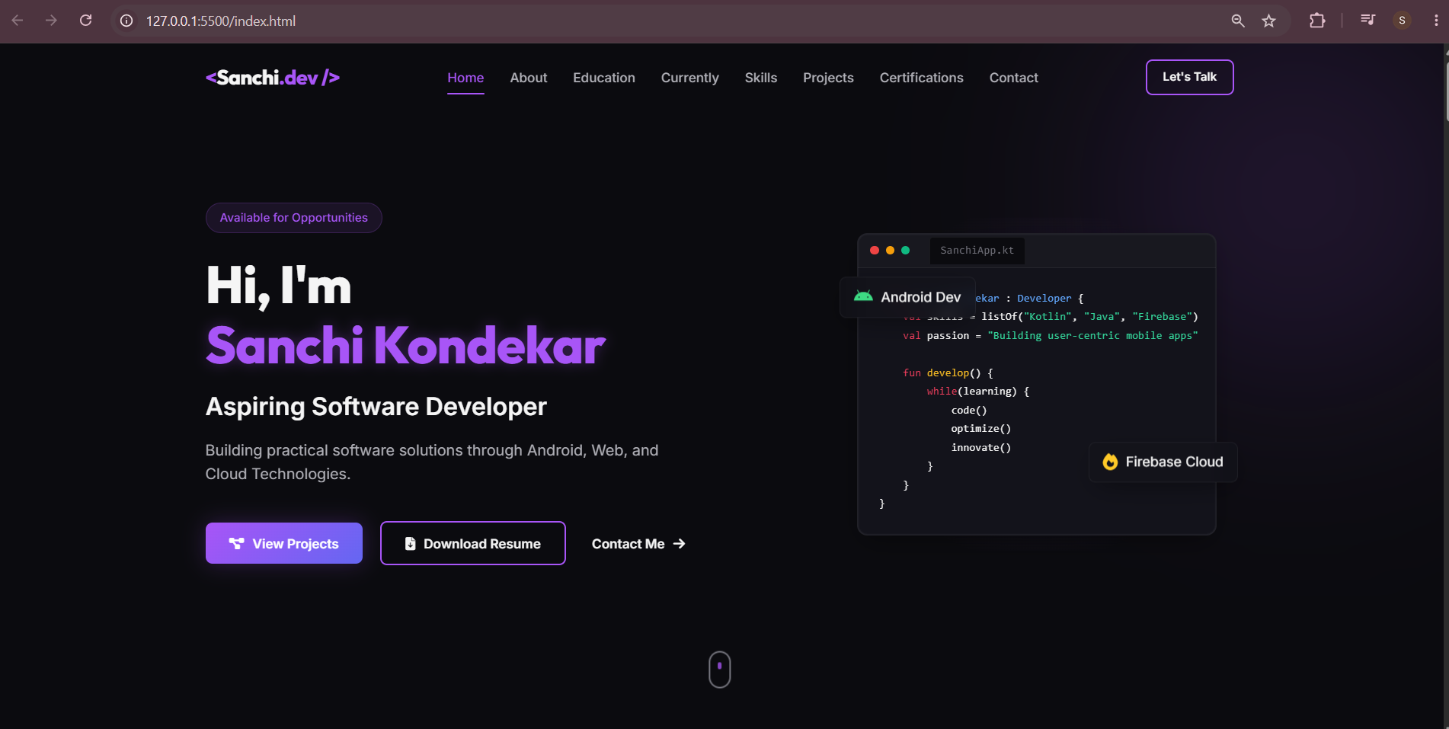
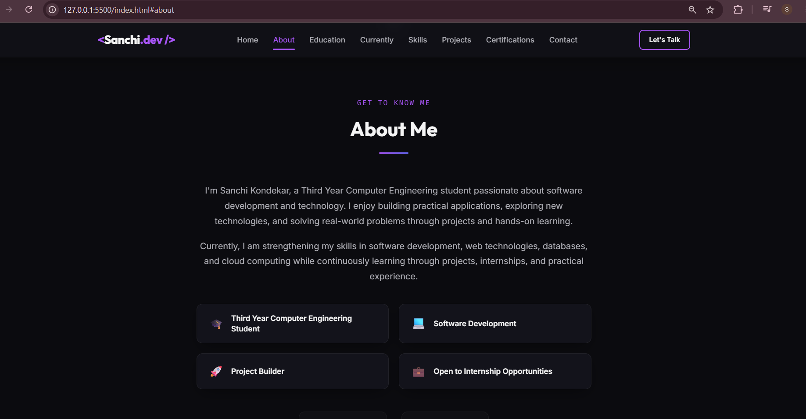
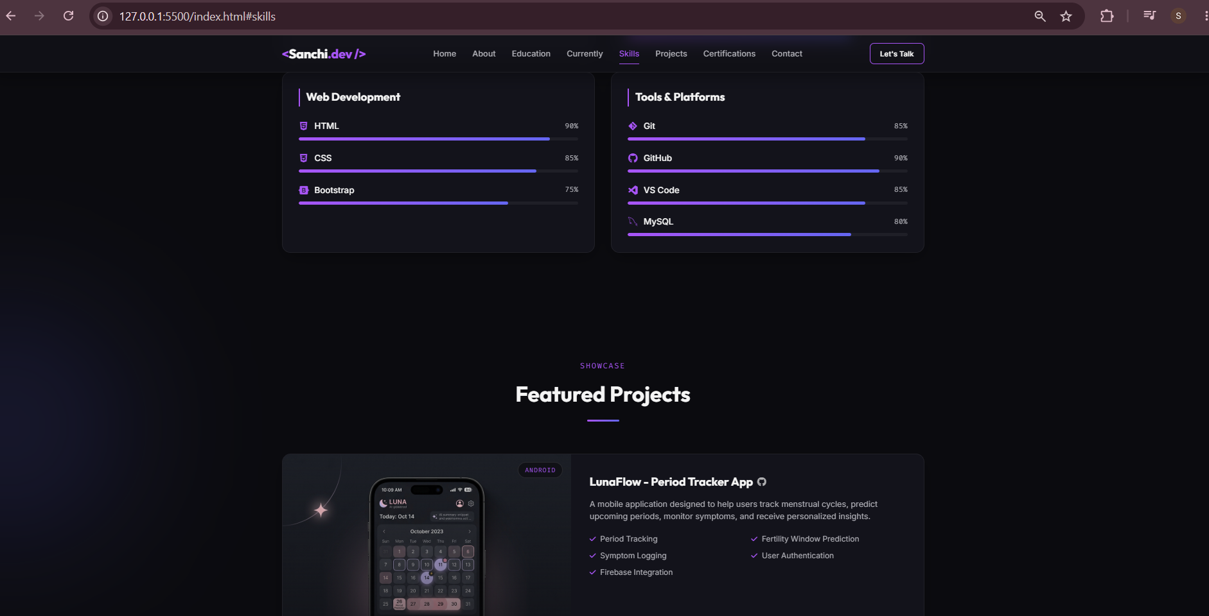

Project 2: Temperature Converter Website
Project Overview
The Temperature Converter Website is an interactive web application that allows users to convert temperature values between Celsius, Fahrenheit, and Kelvin. The project focuses on implementing JavaScript logic, input validation, and dynamic result display.
Objectives
- Develop a functional temperature conversion tool
- Implement JavaScript-based calculations
- Practice user input validation
- Create a simple and user-friendly interface
Features Implemented
- Temperature input field
- Input validation
- Unit selection functionality
- Celsius conversion
- Fahrenheit conversion
- Kelvin conversion
- Dynamic result display
- Responsive user interface
Technologies Used
- HTML5
- CSS3
- JavaScript
My Contribution
I designed the user interface, implemented the temperature conversion formulas, handled user input validation, and developed the functionality required for accurate temperature conversion between multiple units.
Screenshots
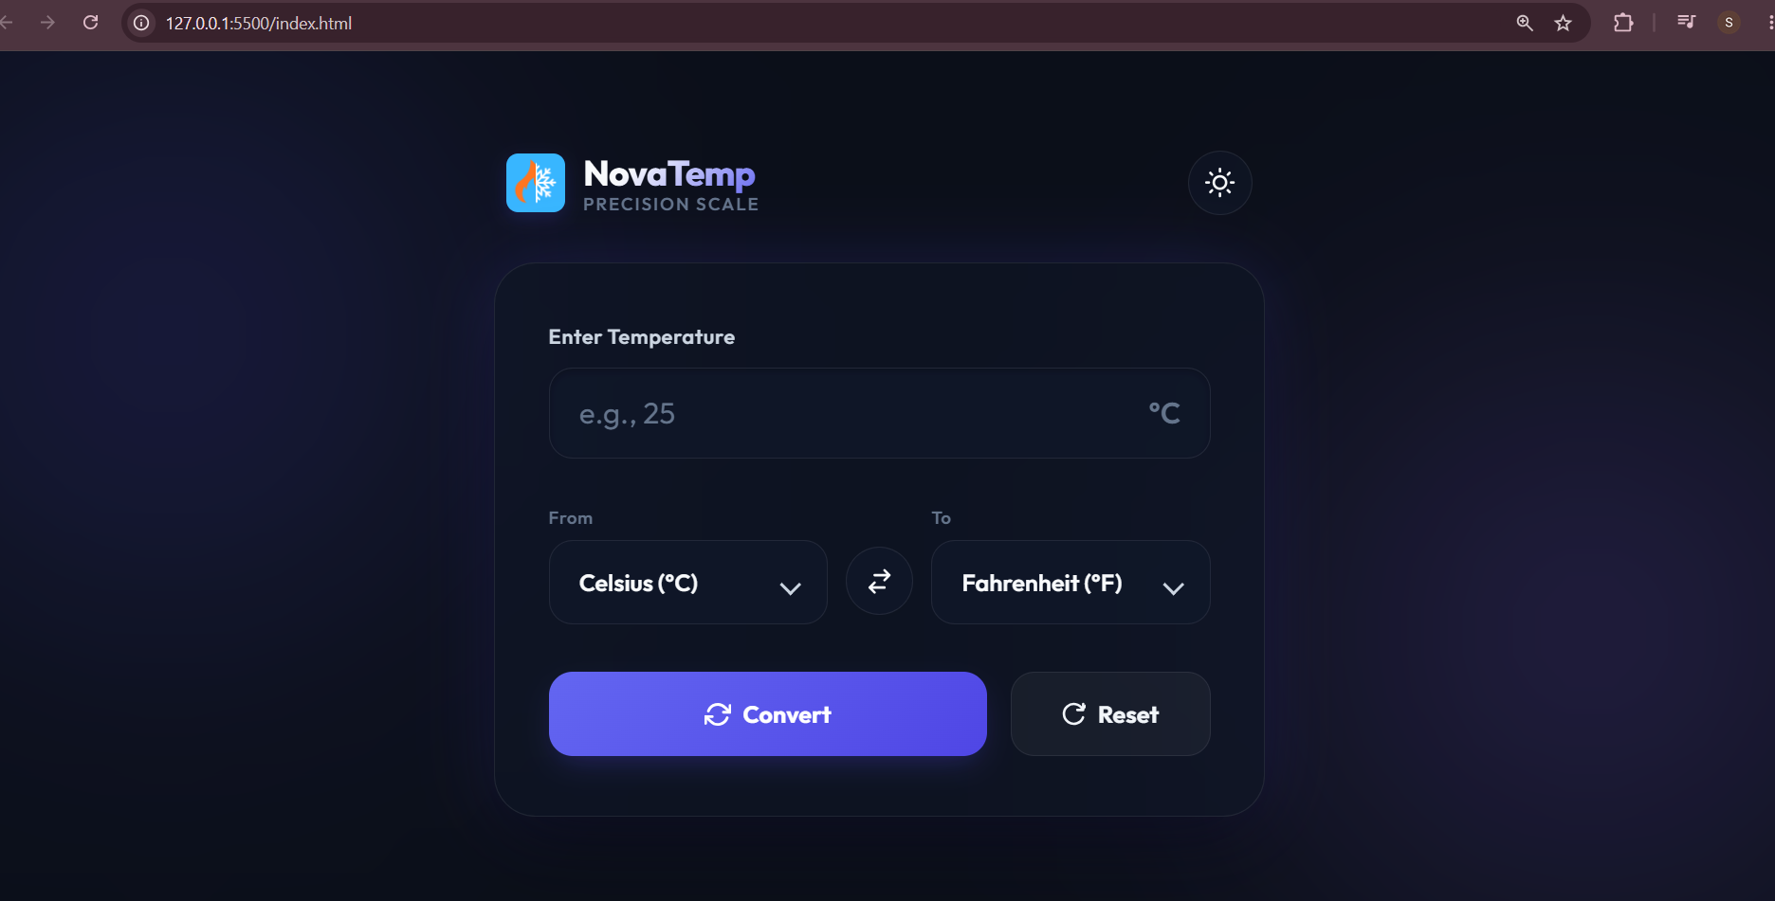
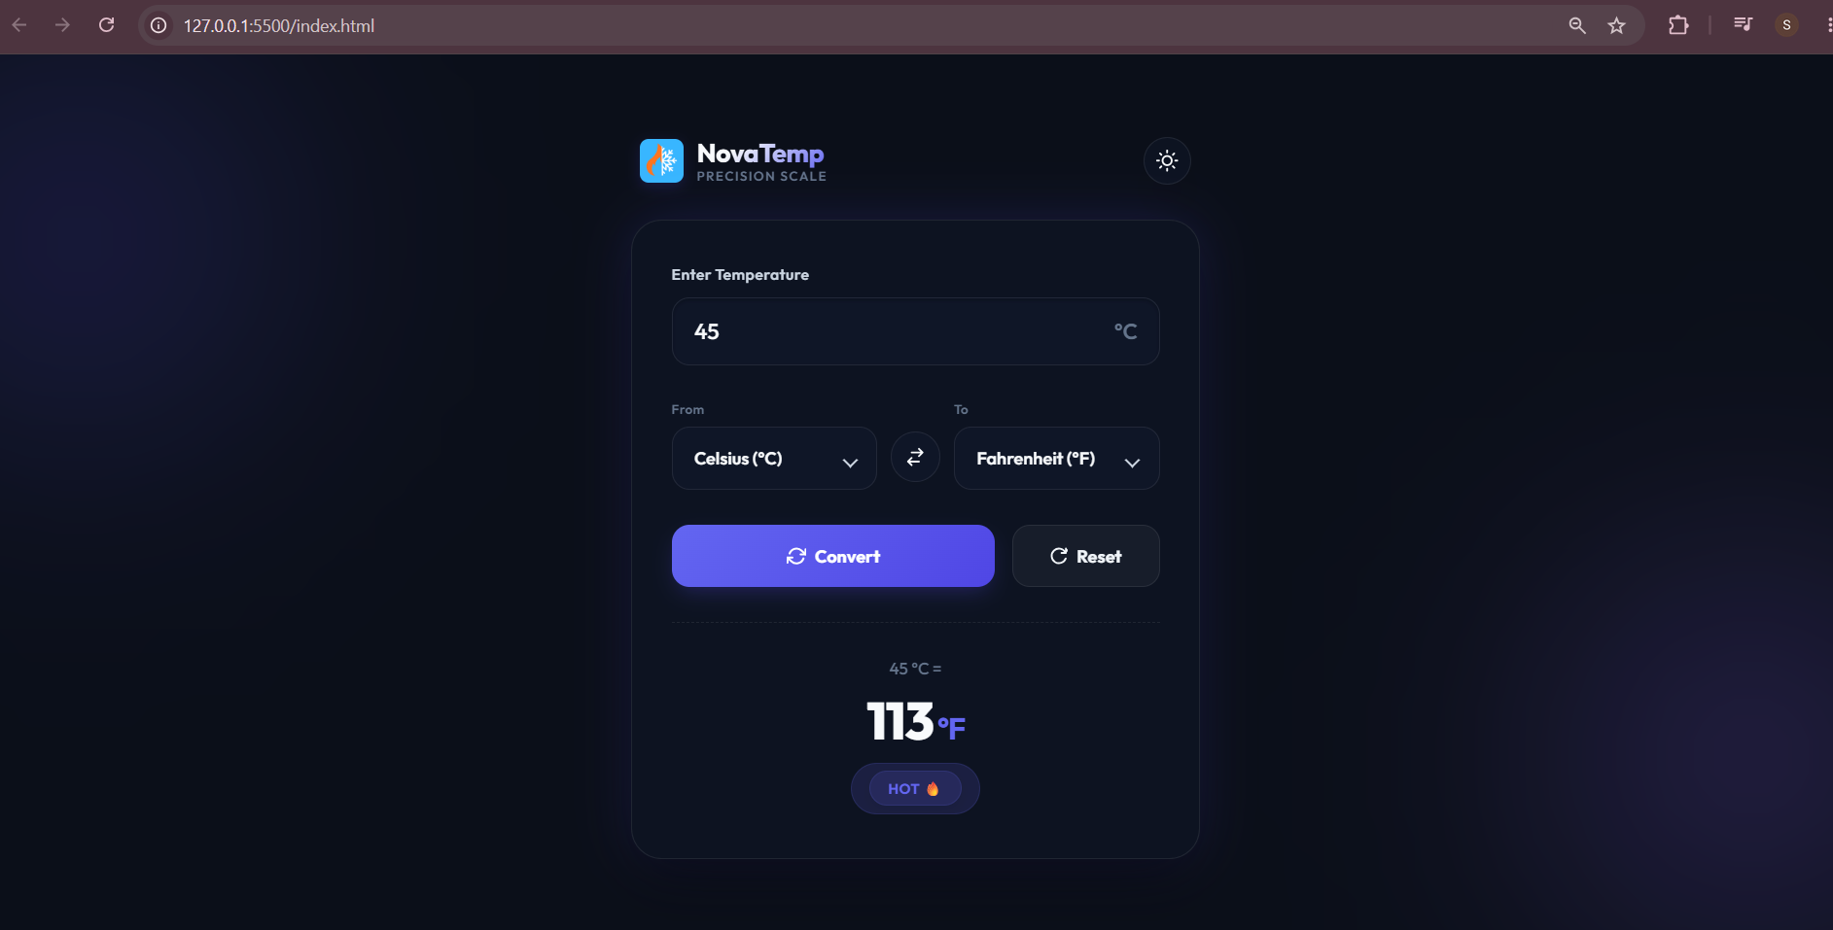

Project 3: Tribute Page
Project Overview
The Tribute Page is dedicated to Grace Hopper, a pioneer in computer science and one of the most influential figures in programming history. The website highlights her life, achievements, and contributions to technology through a clean and informative design.
Objectives
- Create an informative tribute webpage
- Practice content organization and webpage layout design
- Develop an attractive and responsive user interface
- Highlight the achievements of an inspiring personality
Features Implemented
- Hero section
- Biography section
- Achievements section
- Contribution highlights
- Responsive design
- Modern visual layout
Technologies Used
- HTML5
- CSS3
My Contribution
I researched relevant information about Grace Hopper, structured the webpage content, designed the interface, implemented styling, and developed a responsive layout to ensure a visually appealing user experience.
Screenshots
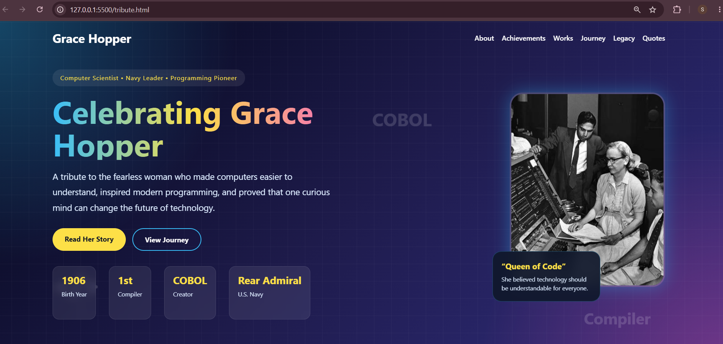
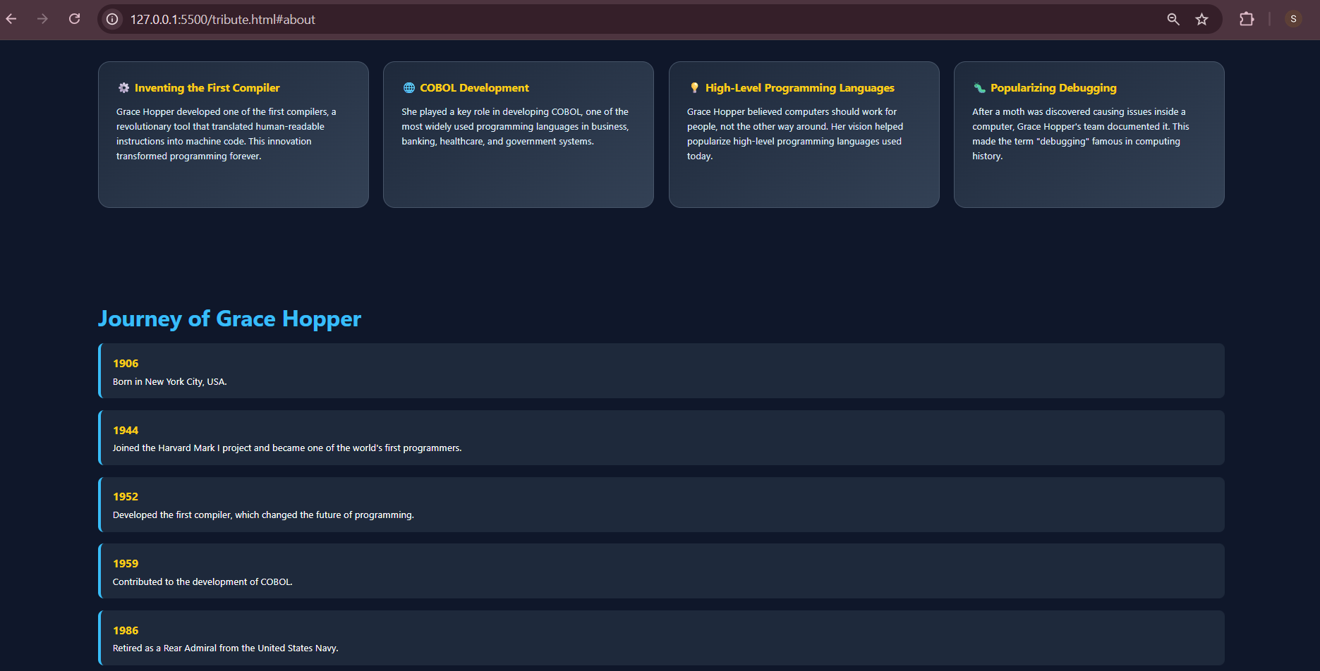

Learning Outcomes
Through these projects, I gained practical experience in:
- Front-End Web Development
- HTML Page Structuring
- CSS Styling and Responsive Design
- JavaScript Programming
- DOM Manipulation
- User Interface Design
- Project Documentation
- Git and GitHub Repository Management
These tasks strengthened my understanding of how to develop, organize, and document web-based projects in a professional environment.

Conclusion
The completion of these projects provided valuable hands-on experience in web development and project management. Each task contributed to improving my technical skills, problem-solving abilities, and understanding of industry-standard development practices.
The internship tasks successfully enhanced my confidence in designing responsive websites, implementing interactive functionality, and maintaining structured project documentation.

GitHub Repository
GitHub Repository:
https://github.com/sanchikondekar/learnova-internship-tasks
Developed and Submitted by:
Sanchi Kondekar

